Chapter 5 Homework

1. Would not let me input .5 MB.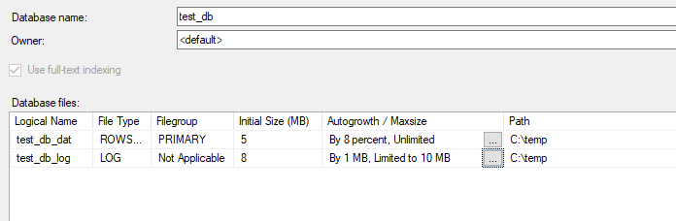

2. 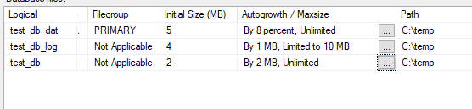

3. 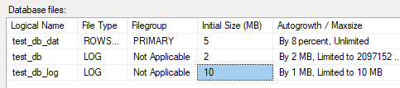

5. They are CHAR values because it is alphanumeric values.

10. Deleting a table with DROP TABLE, all data attached to the table is also dropped.